|  |  |
| --- | --- |
| **ch19.ReactJS Events** | **Date: 22-02-2022** |

**Topics**

React Props Validation,

# React Props Validation

# React Events

An event is an action that could be triggered as a result of the user action or system generated event. For example, a mouse click, loading of a web page, pressing a key, window resizes, and other interactions are called events.

React has its own event handling system which is very similar to handling events on DOM elements. The react event handling system is known as Synthetic Events. The synthetic event is a cross-browser wrapper of the browser's native event.

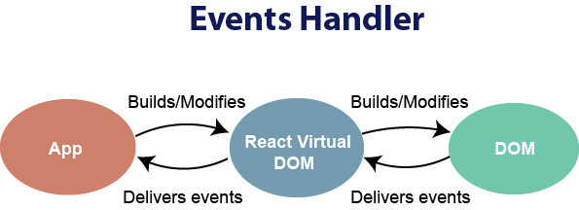

Handling events with react have some syntactic differences from handling events on DOM. These are:

1. React events are named as **camelCase** instead of **lowercase**.
2. With JSX, a function is passed as the **event handler** instead of a **string**. For example:

**Event declaration in plain HTML:**

1. <button onclick="showMessage()">
2. Hello JavaTpoint
3. </button>

**Event declaration in React:**

1. <button onClick={showMessage}>
2. Hello JavaTpoint
3. </button>

3. In react, we cannot return **false** to prevent the **default** behavior. We must call **preventDefault** event explicitly to prevent the default behavior. For example:

In plain HTML, to prevent the default link behavior of opening a new page, we can write:

1. <a href="#" onclick="console.log('You had clicked a Link.'); return false">
2. Click_Me
3. </a>

In React, we can write it as:

1. function ActionLink() {
2. function handleClick(e) {
3. e.preventDefault();
4. console.log('You had clicked a Link.');
5. }
6. **return** (
7. <a href="#" onClick={handleClick}>
8. Click_Me
9. </a>
10. );
11. }

In the above example, e is a **Synthetic Event** which defines according to the **W3C** spec.

Now let us see how to use Event in React.

### **Example**

In the below example, we have used only one component and adding an onChange event. This event will trigger the **changeText** function, which returns the company name.

1. **import** React, { Component } from 'react';
2. **class** App **extends** React.Component {
3. constructor(props) {
4. **super**(props);
5. **this**.state = {
6. companyName: ''
7. };
8. }
9. changeText(event) {
10. **this**.setState({
11. companyName: event.target.value
12. });
13. }
14. render() {
15. **return** (
16. <div>
17. <h2>Simple Event Example</h2>
18. <label htmlFor="name">Enter company name: </label>
19. <input type="text" id="companyName" onChange={**this**.changeText.bind(**this**)}/>
20. <h4>You entered: { **this**.state.companyName }</h4>
21. </div>
22. );
23. }
24. }
25. export **default** App;

**Output**

When you execute the above code, you will get the following output.

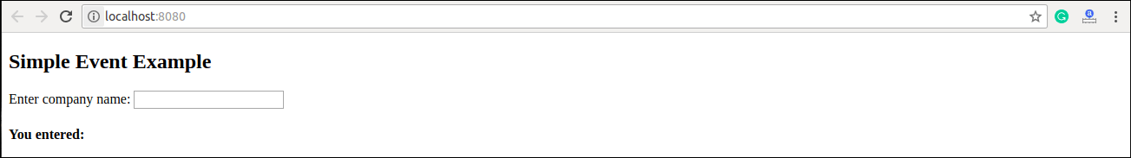

After entering the name in the textbox, you will get the output as like below screen.

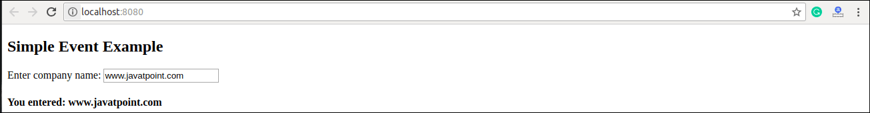

Next Topic[React Conditional Rendering](https://www.javatpoint.com/react-conditional-rendering)